



MarketPulse
Social Media Marketing Campaign Analysis
Capstone Project Report
Using Microsoft Power BI
Submitted in partial fulfillment of completion of the course
AI MicroDegree
Year 2026

Submitted by:
Arsheta Saxena
Kashish Gautam
Tripti
Kavita
Anuradha

Under Guidance of:
Deepika Singh (Edunet)
Abstract

MarketPulse – Social Media Marketing Campaign Analysis is an interactive Business Intelligence dashboard developed using Microsoft Power BI to analyze and monitor the performance of marketing campaigns across multiple digital channels. The project focuses on evaluating key marketing metrics such as clicks, impressions, conversion rate, customer engagement, campaign reach, and Return on Investment (ROI).
The system integrates marketing data from CSV datasets and transforms it into meaningful visual insights using Power Query, DAX calculations, and interactive Power BI visualizations. The dashboard provides real-time analytical capabilities through KPI cards, trend analysis, geographic insights, customer segmentation, and campaign comparison reports.
The primary objective of the project is to help organizations understand campaign effectiveness, identify high-performing marketing channels, optimize resource allocation, and improve business decision-making using data-driven insights.
The dashboard includes advanced features such as dynamic slicers, drill-through analysis, KPI monitoring, trend forecasting, and interactive filtering, making the system user-friendly and highly effective for marketing analysis.
Overall, the project demonstrates how Business Intelligence tools and data visualization techniques can improve marketing strategies, increase operational efficiency, and support better business growth.

Acknowledgement

We would like to express our sincere gratitude to everyone who supported and guided us throughout the successful completion of the project titled “MarketPulse – Social Media Marketing Campaign Analysis.”
We are deeply thankful to our mentor, Deepika Singh (Edunet), for her valuable guidance, continuous encouragement, and constructive suggestions during every phase of the project development.
We also extend our gratitude to our institution and faculty members for providing us with the necessary resources, support, and learning environment required to complete this project successfully.
Special thanks to Microsoft Power BI and related learning resources that helped us understand data visualization, Business Intelligence concepts, and dashboard development.
Finally, we would like to thank our teammates and everyone who directly or indirectly contributed to this project.

Team Composition and Workload Division

Arsheta Saxena | Developed dashboard design, visual layouts, DAX measures, and documentation support
Kashish Gautam | Created Power BI dashboard, KPI structure, data modeling, and report formatting
Tripti | Designed PowerPoint presentation and contributed to video editing
Kavita | Assisted in presentation design, documentation support, and project coordination
Anuradha | Helped in documentation writing and presentation content preparation

Table of Contents

Abstract...................................................................................................... 2
Acknowledgement ..................................................................................... 3
Team Composition and Workload Division ................................................ 4
- Introduction to the Problem .............................................................. 6
- Literature Review ............................................................................. 6
- Problem Statement ……………………………………………………... 7
- Proposed Solution ............................................................................ 7
- Project Requirements ....................................................................... 8
4.1 Technology Stack
4.2 Hardware Requirements
4.3 Software Requirements
4.4 Deployment Environment
- User Requirements .......................................................................... 9
- Design Documentation ....................................................................10
- Implementation Details ................................................................... 10
- Testing and Validation .................................................................... 10
- Deployment ............................................................................ 10
- Future Scope ......................................................................... 11
- Conclusion ..............................................................................11
Appendix A – Project Code ............................................................. 12
Appendix B – Project Screenshots .................................................. 13
Appendix C – Abbreviations ............................................................ 19
References ...................................................................................... 19

- Introduction to Problem
Modern businesses invest heavily in digital marketing campaigns through platforms such as social media, email marketing, influencer marketing, and online advertising. However, marketing data is often scattered across different platforms and formats, making it difficult for organizations to analyze overall campaign performance effectively.

Due to fragmented data sources, businesses face several challenges such as:
- Difficulty in tracking campaign performance
- Limited visibility of customer engagement
- Inefficient allocation of marketing budgets
- Poor understanding of Return on Investment (ROI)
- Delayed decision-making processes

Traditional reporting methods are time-consuming and fail to provide interactive and real-time insights.
Therefore, there is a strong need for a centralized Business Intelligence solution that can consolidate marketing data, visualize performance metrics, and support data-driven decision-making.
This project addresses these challenges by developing an interactive Power BI dashboard named “MarketPulse – Social Media Marketing Campaign Analysis.”

- Literature Review
Business Intelligence and data visualization tools play an important role in modern organizations by transforming raw data into actionable insights. Several studies have shown that interactive dashboards improve decision-making by simplifying complex datasets into understandable visual formats.
Research indicates that marketing analytics dashboards help organizations monitor campaign effectiveness, track customer engagement, and optimize advertising strategies. KPI-based monitoring systems enable businesses to identify high-performing campaigns and improve marketing efficiency.
Microsoft Power BI has become one of the most widely used Business Intelligence platforms due to its interactive visualizations, real-time analytics capabilities, data transformation tools, and user-friendly interface.
Previous studies and industry practices demonstrate that dashboards with features such as geographic analysis, customer segmentation, trend forecasting, and KPI tracking significantly improve business intelligence processes.
This project uses these concepts to build a centralized analytical solution for marketing campaign analysis.

- Problem Statement
Organizations often struggle to consolidate marketing data from multiple channels into a single platform for analysis. As a result, businesses face difficulties in monitoring campaign effectiveness, customer engagement, ROI, and overall marketing performance.
The lack of interactive analytical tools leads to inefficient decision-making and poor optimization of marketing strategies.
The project aims to develop an interactive and centralized Power BI dashboard capable of analyzing marketing campaign data efficiently through meaningful visualizations and KPI tracking.

- Proposed Solution
The proposed solution is the development of an interactive Business Intelligence dashboard using Microsoft Power BI.
The dashboard integrates marketing campaign data from CSV datasets and transforms it into interactive visual reports using:
- Power Query for data cleaning
- DAX for calculations and KPI creation
- Power BI visualizations for analytics
The dashboard enables users to:
- Monitor campaign performance
- Analyze customer engagement
- Compare marketing channels
- Evaluate ROI and conversion rates
- Perform geographic analysis
- Track marketing trends over time
The system supports data-driven decision-making and improves overall marketing efficiency.

- Project Requirements

  - Technology Stack
    - Microsoft Power BI – Dashboard creation and analytics.
    - Excel / CSV Files – For storing and managing the dataset.
    - Power Query – For data cleaning and transformation.
    - DAX (Data Analysis Expressions) – For calculations and creating measures.

  - Hardware
    - Processor: Intel Core i3 or higher.
    - RAM: Minimum 4 GB.
    - Storage: At least 10 GB free disk space.
    - System Type: 64-bit operating system.
    - Operating System: Window 10/11.

  - Software
    - Microsoft Power BI Desktop – For creating and designing the dashboard.
    - Microsoft Excel – For data storage and basic data handling.
    - Windows Operating System – For running Power BI smoothly.

  - Deployment Environment
The project is deployed using Microsoft Power BI, which allows the dashboard to be accessed and shared easily. The dashboard can be published on Power BI Service (Cloud Platform), enabling users to view it through a web browser.
It can also be shared with others via links or integrated into websites and reports. This cloud-based environment ensures accessibility, real-time updates, and easy collaboration among users.

- User Requirements
The system is designed to help users easily analyze and monitor marketing campaign performance through an interactive dashboard. Users should be able to view overall performance along with key metrics such as clicks, impressions, ROI, and customer engagement. The dashboard should allow filtering based on campaign type, location, and time period to provide customized insights. Additionally, it should be user-friendly and present data in a clear visual format, enabling users to make effective and data-driven decisions.

- Design Documentation
The dashboard is designed to be simple, interactive, and user-friendly. It includes sections like summary, campaign performance, geographic analysis, and trends. Visuals such as charts and KPI cards are used to display key metrics, along with filters for easy data analysis and navigation.

- Implementation Details
The implementation of this project is carried out using Microsoft Power BI. The dataset is first imported from Excel/CSV files and cleaned using Power Query. After data preparation, necessary calculations and measures are created using DAX.
Various visualizations such as charts, KPI cards, and maps are then added to represent key metrics like clicks, impressions, ROI, and engagement. Filters and slicers are applied to make the dashboard interactive. Finally, the dashboard is tested and published for user access and analysis.

- Testing and Validation
The dashboard is tested to ensure accuracy, functionality, and usability. Data values are verified to check correct calculations of metrics like clicks, impressions, and ROI. All visuals, filters, and slicers are tested to ensure they respond correctly to user interactions.
Additionally, the dashboard is checked for proper layout, performance, and ease of use, ensuring that users can smoothly navigate and analyze the data without errors.

- Deployment
The dashboard is deployed using Microsoft Power BI by publishing it to the Power BI Service. This allows users to access the dashboard through a web browser. It can be shared via links or integrated into reports and websites.
The deployment ensures easy accessibility, real-time updates, and smooth sharing of insights among users.

- Future Scope
The project can be further enhanced by integrating real-time data sources to provide live updates. Advanced features like predictive analytics and machine learning can be added to forecast campaign performance. Additionally, more detailed customer segmentation and automated report generation can improve analysis and usability.
Further improvements can include mobile-friendly dashboards for better accessibility.

- Conclusion
The Marketing Campaign Performance Dashboard effectively provides a centralized and interactive platform for analyzing marketing data. It helps in tracking key metrics such as clicks, impressions, ROI, and customer engagement across different channels.
By using clear visualizations and insights, the dashboard supports better decision-making and improves overall campaign performance. This project demonstrates the importance of data-driven strategies in achieving business success.

Appendix A - Project Code

Appendix B - Project Screenshot

Overview Dashboard

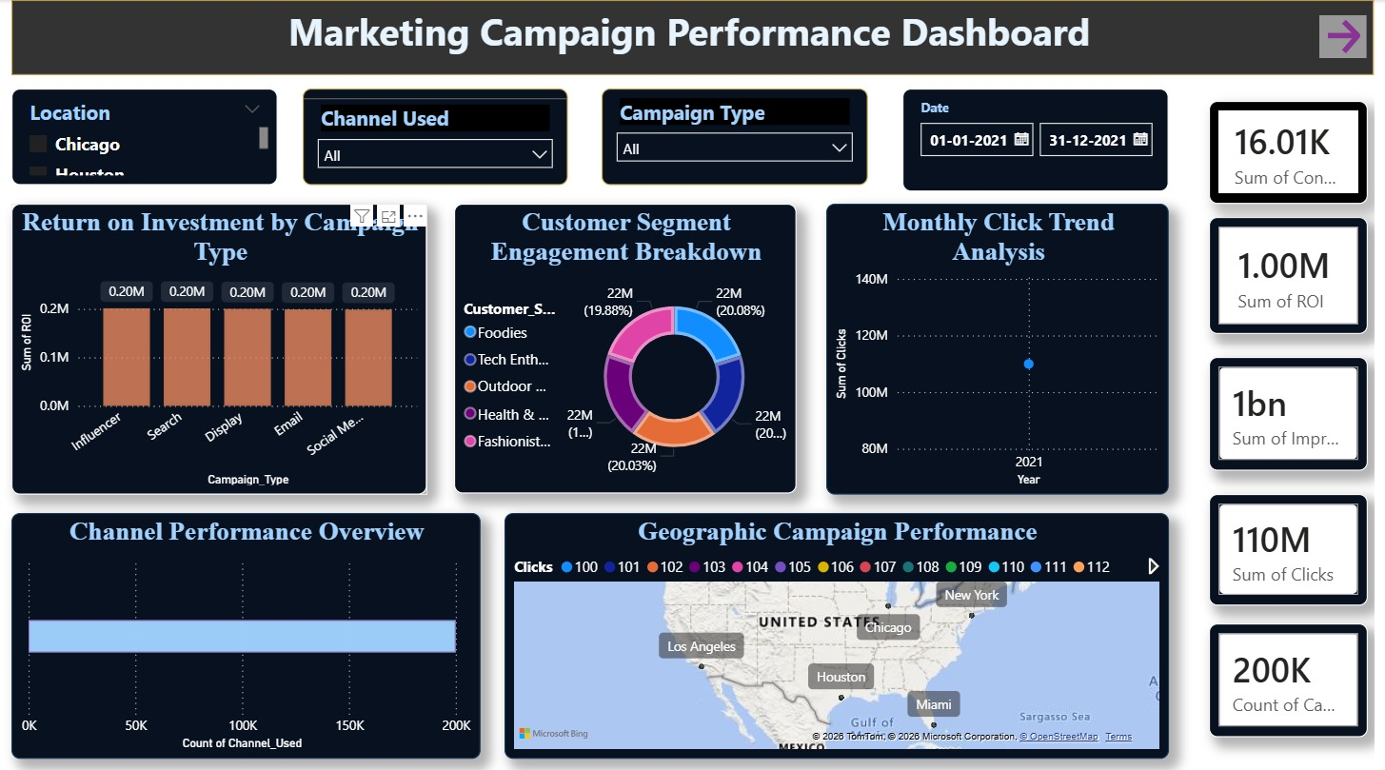

EXECUTIVE SUMMARY

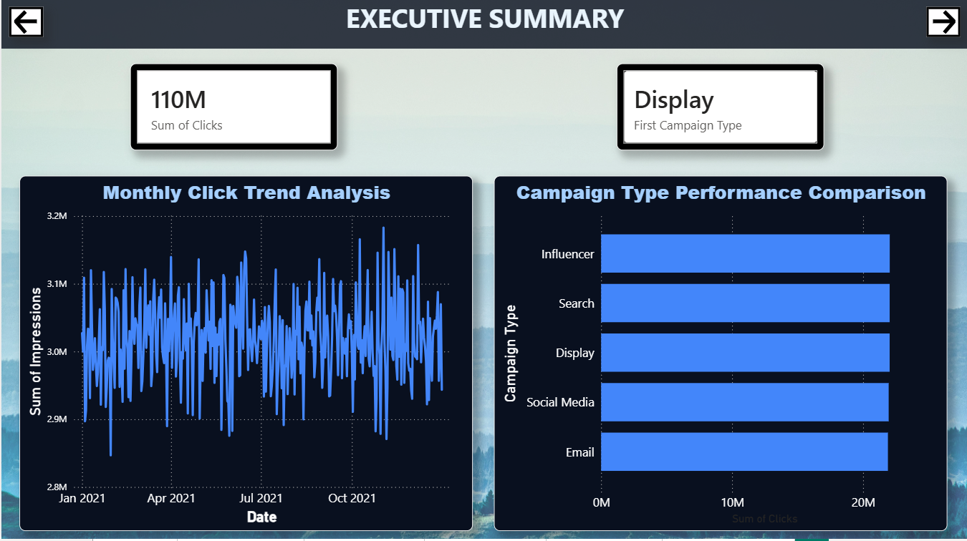

CAMPAIGN ANALYSIS

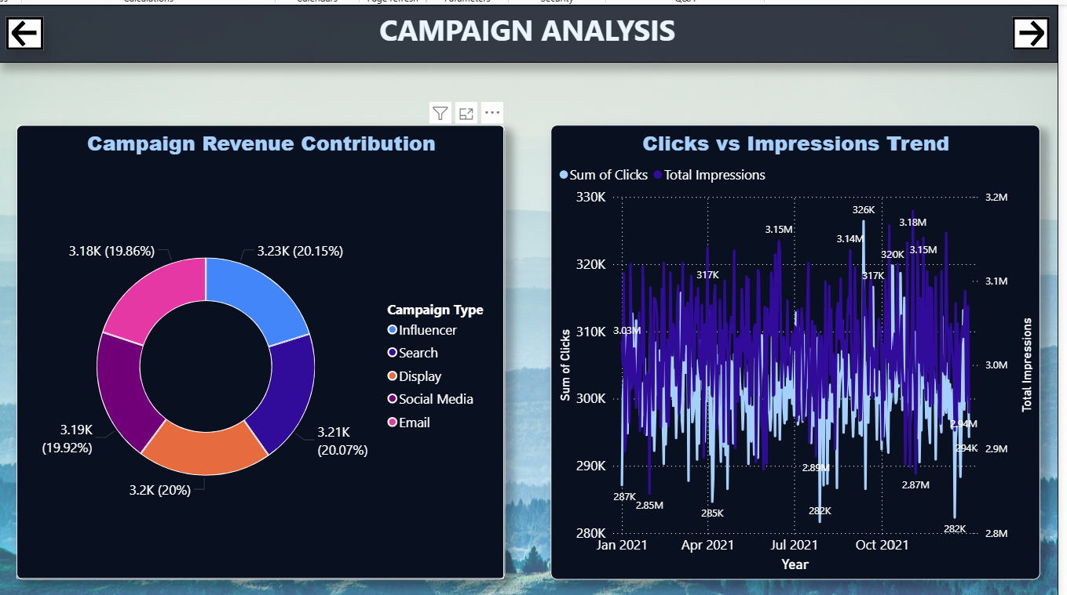

CUSTOMER SEGMENT

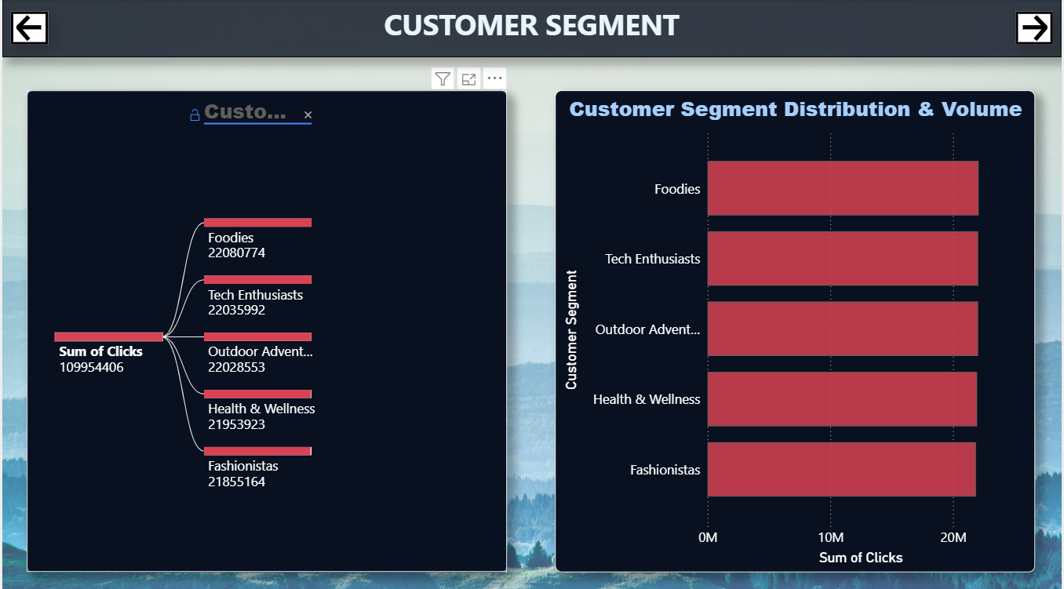

GEO ANALYSIS

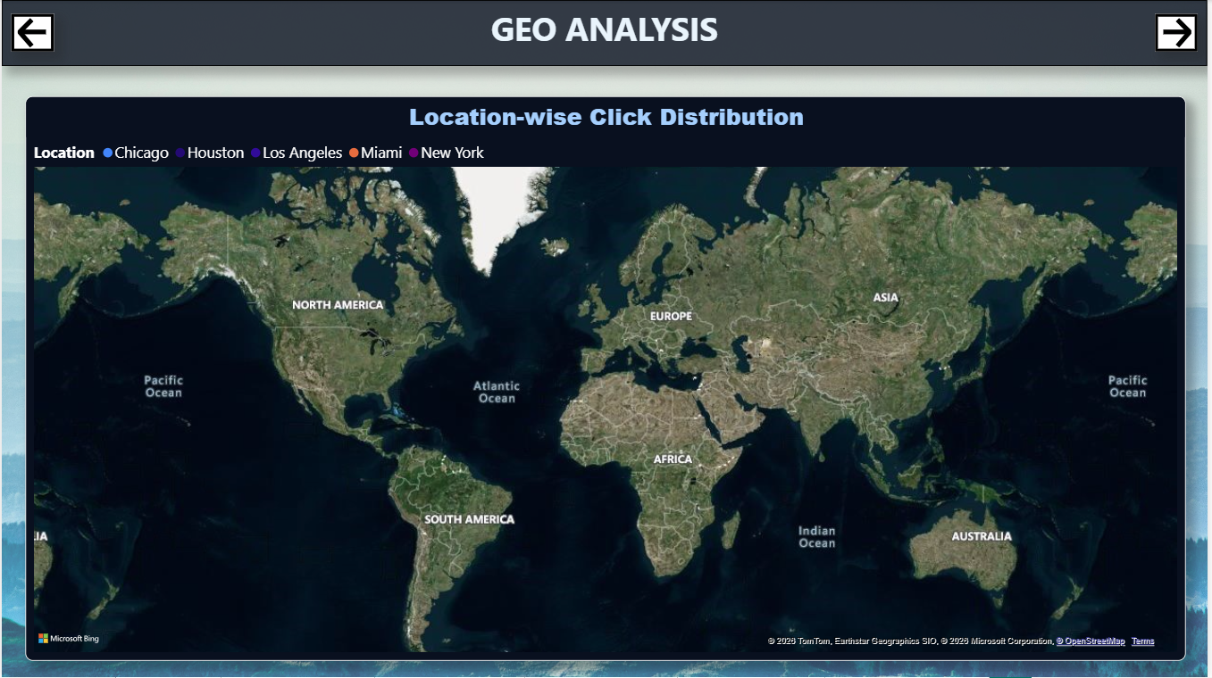

CHANNEL PERFORMANCE

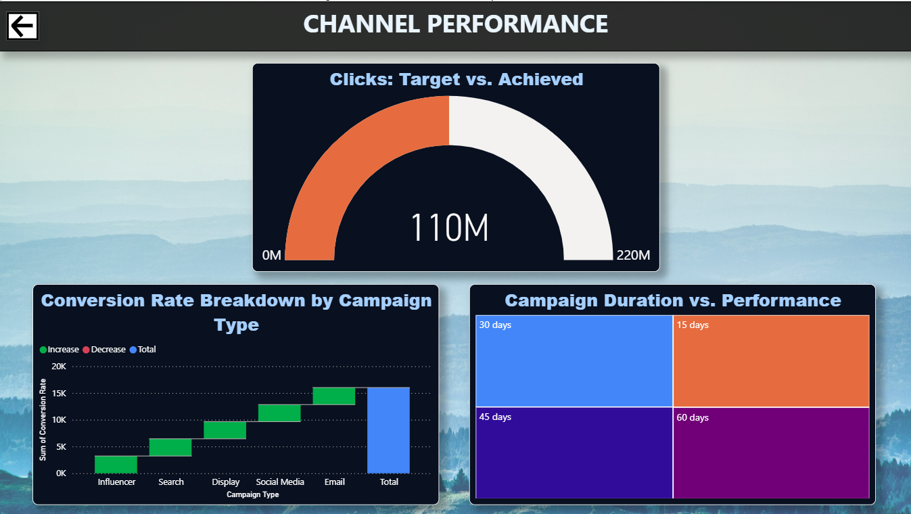

Appendix C - Abbreviations
  - ROI – Return on Investment
  - KPI – Key Performance Indicator
  - BI – Business Intelligence
  - DAX – Data Analysis Expressions
  - CSV – Comma Separated Values
  - UI – User Interface
  - UX – User Experience
  - ETL – Extract, Transform, Load
  - API – Application Programming Interface

References
[1] Microsoft Power BI Official Documentation.
[2] Microsoft Excel Documentation.
[3] Kaggle Marketing Dataset Resources https://www.kaggle.com/datasets/manishabhatt22/marketing-campaign-performance-dataset
[4] Research articles on Marketing Campaign Analysis and Data Visualization.
[5] Online tutorials and learning resources related to Power BI and DAX.
[6] Articles on Business Intelligence and Dashboard Design.

These references were used to understand concepts and implement the project effectively.

